Nama : Frederico Steven Kwok
NPM : 242310037
Kelas : TI-24-PA1
Mata Kuliah : Lab. Pemrograman Perangkat Bergerak
Tugas : Pertemuan 7 – Tugas dan Latihan
Github : https://github.com/RicoSteven120206/PPB-Praktikum-242310037.git
Pada tugas praktikum ini, akan mengimplementasikan pemanfaatan fitur perangkat (device features) dalam aplikasi mobile yang telah dikembangkan sebelumnya. Fokus utama pada bab ini adalah bagaimana aplikasi dapat berinteraksi langsung dengan kemampuan perangkat seperti kamera, media library, dan sistem pemindaian QR Code.
Mahasiswa diminta untuk mengembangkan dua fitur utama, yaitu:
Latihan 1:
Membuat Halaman Profile Yang Dapat Memperbaharui Data Prbadi dan Avatar Pengguna
- Membuat tampilan untuk halaman profile yang dapat memperbarui data dan avatar, berikut Source Code untuk pengembangannya.
Source Code pada main-apps/(tabs)/profile.jsx
import { Ionicons } from "@expo/vector-icons";
import * as ImagePicker from "expo-image-picker";
import { useState } from "react";
import {
Alert,
Image,
ScrollView,
Text,
TextInput,
TouchableOpacity,
View,
} from "react-native";
import { SafeAreaView } from "react-native-safe-area-context";
import { color_list, styles } from "../../styles/StyleApps";

export default function ProfileScreen() {
const [avatar, setAvatar] = useState(null);
const [isEditing, setIsEditing] = useState(false);

const [profile, setProfile] = useState({
name: "Frederico Steven Kwok",
email: "frederico.steven@example.com",
bio: "Pecinta buku fiksi dan non-fiksi. Selalu mencari cerita baru.",
});

const [tempProfile, setTempProfile] = useState(profile);

const pickImage = async () => {
const { status } = await ImagePicker.requestMediaLibraryPermissionsAsync();

if (status !== "granted") {
Alert.alert(
"Izin ditolak",
"Aplikasi membutuhkan akses galeri untuk mengubah foto profil."
);
return;
}

const result = await ImagePicker.launchImageLibraryAsync({
mediaTypes: ImagePicker.MediaTypeOptions.Images,
allowsEditing: true,
aspect: [1, 1],
quality: 0.7,
});

if (!result.canceled) {
setAvatar(result.assets[0].uri);
}
};

const handleSave = () => {
if (!tempProfile.name.trim()) {
Alert.alert("Nama tidak boleh kosong", "Silakan isi nama Anda.");
return;
}
setProfile(tempProfile);
setIsEditing(false);
Alert.alert("Berhasil", "Profil Anda telah diperbarui.");
};

const handleCancel = () => {
setTempProfile(profile);
setIsEditing(false);
};

return (
<SafeAreaView style={styles.container}>
<ScrollView showsVerticalScrollIndicator={false}>
<View style={{ alignItems: "center", marginTop: 20 }}>
<TouchableOpacity onPress={isEditing ? pickImage : undefined}>
<View style={{ position: "relative" }}>
{avatar ? (
<Image
source={{ uri: avatar }}
style={{ width: 110, height: 110, borderRadius: 55 }}
/>
) : (
<View
style={{
width: 110,
height: 110,
borderRadius: 55,
backgroundColor: color_list.green_light,
justifyContent: "center",
alignItems: "center",
}}
>
<Ionicons
name="person"
size={50}
color={color_list.green}
/>
</View>
)}
{isEditing && (
<View
style={{
position: "absolute",
bottom: 0,
right: 0,
width: 32,
height: 32,
borderRadius: 16,
backgroundColor: color_list.green,
justifyContent: "center",
alignItems: "center",
borderWidth: 2,
borderColor: "#fff",
}}
>
<Ionicons name="camera" size={16} color="#fff" />
</View>
)}
</View>
</TouchableOpacity>

{!isEditing && (
<>
<Text style={{ fontSize: 20, fontWeight: "bold", marginTop: 12 }}>
{profile.name}
</Text>
<Text style={{ color: "gray", marginTop: 4 }}>{profile.email}</Text>
</>
)}
</View>

<View style={{ marginTop: 30 }}>
<FieldRow
label="Nama Lengkap"
value={isEditing ? tempProfile.name : profile.name}
editable={isEditing}
onChangeText={(text) =>
setTempProfile((prev) => ({ ...prev, name: text }))
}
/>
<FieldRow
label="Email"
value={isEditing ? tempProfile.email : profile.email}
editable={isEditing}
keyboardType="email-address"
onChangeText={(text) =>
setTempProfile((prev) => ({ ...prev, email: text }))
}
/>
<FieldRow
label="Bio"
value={isEditing ? tempProfile.bio : profile.bio}
editable={isEditing}
multiline
onChangeText={(text) =>
setTempProfile((prev) => ({ ...prev, bio: text }))
}
/>
</View>

<View style={{ marginTop: 30, gap: 10 }}>
{isEditing ? (
<>
<TouchableOpacity
style={{
backgroundColor: color_list.green,
paddingVertical: 14,
borderRadius: 12,
alignItems: "center",
}}
onPress={handleSave}
>
<Text style={{ color: "#fff", fontWeight: "bold", fontSize: 16 }}>
Simpan Perubahan
</Text>
</TouchableOpacity>
<TouchableOpacity
style={{
paddingVertical: 14,
borderRadius: 12,
alignItems: "center",
borderWidth: 1,
borderColor: "gray",
}}
onPress={handleCancel}
>
<Text style={{ color: "gray", fontWeight: "600" }}>Batal</Text>
</TouchableOpacity>
</>
) : (
<TouchableOpacity
style={{
backgroundColor: color_list.green,
paddingVertical: 14,
borderRadius: 12,
alignItems: "center",
flexDirection: "row",
justifyContent: "center",
gap: 8,
}}
onPress={() => setIsEditing(true)}
>
<Ionicons name="create-outline" size={20} color="#fff" />
<Text style={{ color: "#fff", fontWeight: "bold", fontSize: 16 }}>
Edit Profil
</Text>
</TouchableOpacity>
)}
</View>
</ScrollView>
</SafeAreaView>
);
}

const FieldRow = ({ label, value, editable, onChangeText, multiline, keyboardType }) => (
<View style={{ marginBottom: 18 }}>
<Text style={{ fontSize: 13, color: "gray", marginBottom: 6 }}>{label}</Text>
{editable ? (
<TextInput
value={value}
onChangeText={onChangeText}
multiline={multiline}
keyboardType={keyboardType}
style={{
borderWidth: 1,
borderColor: "#ddd",
borderRadius: 10,
padding: 12,
fontSize: 15,
minHeight: multiline ? 80 : undefined,
textAlignVertical: multiline ? "top" : "center",
}}
/>
) : (
<Text style={{ fontSize: 15, color: "#1e293b" }}>{value}</Text>
)}
</View>
);

Latihan 2:
Membuat fitur QR Scanner Untuk Membaca QR Code Sebuah Buku dan Menampilkan Detailnya
- Berikut Source Code untuk Fitur QR Scanner untuk Membaca sebuah Buku hanya Scan Buku untuk mendapatkan Detail Buku.
Source Code pada main-apps/(tabs)/qr-scanner.jsx
import { Ionicons } from "@expo/vector-icons";
import { CameraView, useCameraPermissions } from "expo-camera";
import { useRouter } from "expo-router";
import { useState } from "react";
import { Alert, StyleSheet, Text, TouchableOpacity, View } from "react-native";
import { SafeAreaView } from "react-native-safe-area-context";
import ListBook from "../../constants/list_book";
import { color_list } from "../styles/StyleApps";

export default function QRScannerScreen() {
const router = useRouter();
const [permission, requestPermission] = useCameraPermissions();
const [scanned, setScanned] = useState(false);

const handleBarcodeScanned = ({ data }) => {
if (scanned) return;
setScanned(true);

const book = ListBook.find((b) => b.id.toString() === data.toString());

if (book) {
router.replace(`/books/${book.id}`);
} else {
Alert.alert(
"QR Code Tidak Dikenali",
"Buku dengan kode ini tidak ditemukan dalam katalog.",
[{ text: "Coba Lagi", onPress: () => setScanned(false) }]
);
}
};

if (!permission) {
return <View style={qrStyles.container} />;
}

if (!permission.granted) {
return (
<SafeAreaView style={[qrStyles.container, qrStyles.centerAll]}>
<Ionicons name="camera-outline" size={64} color={color_list.green} />
<Text style={qrStyles.permissionText}>
Aplikasi membutuhkan akses kamera untuk memindai QR Code buku
</Text>
<TouchableOpacity
style={qrStyles.permissionButton}
onPress={requestPermission}
>
<Text style={qrStyles.permissionButtonText}>Izinkan Akses Kamera</Text>
</TouchableOpacity>
</SafeAreaView>
);
}

return (
<View style={qrStyles.container}>
<CameraView
style={StyleSheet.absoluteFillObject}
facing="back"
barcodeScannerSettings={{ barcodeTypes: ["qr"] }}
onBarcodeScanned={scanned ? undefined : handleBarcodeScanned}
/>

<SafeAreaView style={qrStyles.overlay}>
<TouchableOpacity
style={qrStyles.backButton}
onPress={() => router.back()}
>
<Ionicons name="arrow-back" size={24} color="#fff" />
</TouchableOpacity>

<View style={qrStyles.scanFrameContainer}>
<View style={qrStyles.scanFrame} />
<Text style={qrStyles.scanHint}>
Arahkan kamera ke QR Code pada sampul buku
</Text>
</View>
</SafeAreaView>
</View>
);
}

const qrStyles = StyleSheet.create({
container: {
flex: 1,
backgroundColor: "black",
},
centerAll: {
justifyContent: "center",
alignItems: "center",
paddingHorizontal: 30,
},
permissionText: {
textAlign: "center",
marginTop: 16,
marginBottom: 20,
fontSize: 15,
color: "#333",
},
permissionButton: {
backgroundColor: color_list.green,
paddingHorizontal: 24,
paddingVertical: 12,
borderRadius: 30,
},
permissionButtonText: {
color: "#fff",
fontWeight: "bold",
},
overlay: {
flex: 1,
justifyContent: "space-between",
},
backButton: {
margin: 20,
width: 44,
height: 44,
borderRadius: 22,
backgroundColor: "rgba(0,0,0,0.5)",
justifyContent: "center",
alignItems: "center",
},
scanFrameContainer: {
alignItems: "center",
marginBottom: 80,
},
scanFrame: {
width: 250,
height: 250,
borderWidth: 3,
borderColor: color_list.orange,
borderRadius: 20,
backgroundColor: "transparent",
},
scanHint: {
color: "#fff",
marginTop: 20,
fontSize: 14,
textAlign: "center",
paddingHorizontal: 30,
},
});

Latihan 3:
Mengimplementasikan fitur perangkat output audio (speaker) yang tidak perlu meminta izin akses perangkat. Buatlah seperti detail buku seperti dibawah ini:
Pada halaman detail buku ini, dapat diubah menjadi audio-book dengan memanfaatkan teknologi text-to-speach.
Manfaatkanlah library package expo-speach dalam mengimplementasikan hal ini. Dimana mengubah sebuah text menjadi sebuah audio dan dikeluarkan melalui speaker device.
Dihalaman ini audio-book dapat di play, pause ataupun stop. Dan memberikan highlight pada text yang sedang dibacakan atau dikonversikan kedalam audio.
- Berikut Source Code yang dikembangkan pada Detail Buku untuk output dari Audio dan Speaker untuk membaca otomatis, dan user hanya mendengarkan saja ketika di play.
Source Code pada /components/books/[id].jsx
import { Ionicons } from "@expo/vector-icons";
import { useLocalSearchParams, useRouter } from "expo-router";
import {
Image,
ScrollView,
StatusBar,
StyleSheet,
Text,
TouchableOpacity,
View,
} from "react-native";
import { SafeAreaView } from "react-native-safe-area-context";

import ListBook from "../../constants/list_book";
import AudioBookPlayer from "./AudioBookPlayer";

export default function BookDetailScreen() {
const { id } = useLocalSearchParams();
const router = useRouter();

const book = ListBook.find((b) => b.id.toString() === id);

if (!book) {
return (
<SafeAreaView style={[styles.container, styles.centerAll]}>
<Text style={styles.errorText}>Buku tidak ditemukan</Text>
<TouchableOpacity
onPress={() => router.back()}
style={{ marginTop: 20 }}
>
<Text style={{ color: "white" }}>Kembali</Text>
</TouchableOpacity>
</SafeAreaView>
);
}

return (
<SafeAreaView style={styles.container}>
<StatusBar barStyle="light-content" backgroundColor="#1a2228" />

<View style={styles.header}>
<TouchableOpacity
onPress={() => router.back()}
style={styles.circleBtn}
>
<Ionicons name="arrow-back" size={24} color="#2D3748" />
</TouchableOpacity>
<View style={styles.headerRight}>
<TouchableOpacity style={styles.circleBtn}>
<Ionicons name="heart" size={24} color="#E2E8F0" />
</TouchableOpacity>
<TouchableOpacity style={styles.circleBtn}>
<Ionicons name="share-social" size={22} color="#2D3748" />
</TouchableOpacity>
</View>
</View>

<ScrollView
showsVerticalScrollIndicator={false}
contentContainerStyle={styles.scrollContent}
>
<Image source={book.img} style={styles.coverImage} />

<Text style={styles.title}>{book.title.toUpperCase()}</Text>
<Text style={styles.author}>{book.author}</Text>

<View style={styles.ratingRow}>
<Ionicons name="star" size={16} color="#EAB308" />
<Text style={styles.ratingText}>{book.rating} / 5.0</Text>
</View>

{/* Bagian ini yang diganti — synopsisText polos jadi AudioBookPlayer */}
<View style={styles.synopsisBox}>
<Text style={styles.synopsisLabel}>SINOPSIS</Text>
<AudioBookPlayer text={book.sinopsis} />

{book.story && (
<>
<Text style={[styles.synopsisLabel, { marginTop: 20 }]}>
STORY
</Text>
<AudioBookPlayer text={book.story} />
</>
)}
</View>
</ScrollView>

<View style={styles.footer}>
{book.is_free ? (
<TouchableOpacity style={[styles.btnAction, styles.btnFree]}>
<Ionicons name="book-outline" size={20} color="#1E293B" />
<Text style={styles.txtFree}>Read Book</Text>
</TouchableOpacity>
) : (
<TouchableOpacity style={[styles.btnAction, styles.btnPremium]}>
<Ionicons name="card-outline" size={20} color="#FFF" />
<Text style={styles.txtPremium}>Subscribe</Text>
</TouchableOpacity>
)}
</View>
</SafeAreaView>
);
}

const styles = StyleSheet.create({
container: {
flex: 1,
backgroundColor: "#1a2228",
},
centerAll: {
justifyContent: "center",
alignItems: "center",
},
errorText: {
color: "#FFF",
fontSize: 18,
fontWeight: "bold",
},
header: {
flexDirection: "row",
justifyContent: "space-between",
paddingHorizontal: 20,
paddingTop: 10,
paddingBottom: 20,
},
headerRight: {
flexDirection: "row",
gap: 15,
},
circleBtn: {
width: 44,
height: 44,
borderRadius: 22,
backgroundColor: "#FFF",
justifyContent: "center",
alignItems: "center",
},
scrollContent: {
alignItems: "center",
paddingHorizontal: 20,
paddingBottom: 40,
},
coverImage: {
width: 200,
height: 200,
borderRadius: 16,
marginBottom: 25,
resizeMode: "cover",
},
title: {
color: "#FFF",
fontSize: 22,
fontWeight: "bold",
textAlign: "center",
marginBottom: 8,
},
author: {
color: "#E2E8F0",
fontSize: 16,
fontWeight: "500",
marginBottom: 10,
},
ratingRow: {
flexDirection: "row",
alignItems: "center",
marginBottom: 30,
},
ratingText: {
color: "#EAB308",
fontSize: 14,
fontWeight: "bold",
marginLeft: 6,
},
synopsisBox: {
width: "100%",
},
synopsisLabel: {
color: "#FFF",
fontSize: 18,
fontWeight: "bold",
marginBottom: 10,
},
synopsisText: {
color: "#CBD5E1",
fontSize: 15,
lineHeight: 24,
textAlign: "justify",
},
footer: {
padding: 20,
paddingBottom: 30,
backgroundColor: "transparent",
},
btnAction: {
flexDirection: "row",
width: "100%",
paddingVertical: 16,
borderRadius: 30,
justifyContent: "center",
alignItems: "center",
gap: 10,
},
btnPremium: {
backgroundColor: "#EAB308",
},
txtPremium: {
color: "#FFF",
fontSize: 18,
fontWeight: "bold",
},
btnFree: {
backgroundColor: "#FFF",
},
txtFree: {
color: "#1E293B",
fontSize: 18,
fontWeight: "bold",
},
});
Source Code pada /components/books/AudioBookPlayer.jsx
import { Ionicons } from "@expo/vector-icons";
import * as Speech from "expo-speech";
import { useEffect, useState } from "react";
import { Text, TouchableOpacity, View } from "react-native";
import { color_list } from "../styles/StyleApps";

const AudioBookPlayer = ({ text }) => {
const [status, setStatus] = useState("idle");
const [boundary, setBoundary] = useState({ charIndex: 0, charLength: 0 });

useEffect(() => {
return () => {
Speech.stop();
};
}, []);

const handlePlay = () => {
if (status === "paused") {
Speech.resume();
setStatus("playing");
return;
}

setStatus("playing");
Speech.speak(text, {
language: "id-ID",
pitch: 1.0,
rate: 0.95,
onBoundary: (event) => {
setBoundary({
charIndex: event.charIndex,
charLength: event.charLength,
});
},
onDone: () => {
setStatus("idle");
setBoundary({ charIndex: 0, charLength: 0 });
},
onStopped: () => {
setStatus("idle");
setBoundary({ charIndex: 0, charLength: 0 });
},
onError: () => {
setStatus("idle");
},
});
};

const handlePause = () => {
Speech.pause();
setStatus("paused");
};

const handleStop = () => {
Speech.stop();
setStatus("idle");
setBoundary({ charIndex: 0, charLength: 0 });
};

const renderHighlightedText = () => {
if (status === "idle" || boundary.charLength === 0) {
return <Text style={{ color: "#CBD5E1", fontSize: 15, lineHeight: 24 }}>{text}</Text>;
}

const before = text.slice(0, boundary.charIndex);
const current = text.slice(
boundary.charIndex,
boundary.charIndex + boundary.charLength
);
const after = text.slice(boundary.charIndex + boundary.charLength);

return (
<Text style={{ fontSize: 15, lineHeight: 24 }}>
<Text style={{ color: "#CBD5E1" }}>{before}</Text>
<Text
style={{
color: "#1a2228",
backgroundColor: color_list.orange,
fontWeight: "bold",
}}
>
{current}
</Text>
<Text style={{ color: "#CBD5E1" }}>{after}</Text>
</Text>
);
};

return (
<View style={{ marginTop: 20 }}>
<View
style={{
flexDirection: "row",
alignItems: "center",
backgroundColor: "#232d36",
borderRadius: 16,
padding: 16,
marginBottom: 16,
}}
>
{status === "playing" ? (
<TouchableOpacity
onPress={handlePause}
style={{
width: 44,
height: 44,
borderRadius: 22,
backgroundColor: color_list.orange,
justifyContent: "center",
alignItems: "center",
}}
>
<Ionicons name="pause" size={22} color="#fff" />
</TouchableOpacity>
) : (
<TouchableOpacity
onPress={handlePlay}
style={{
width: 44,
height: 44,
borderRadius: 22,
backgroundColor: color_list.orange,
justifyContent: "center",
alignItems: "center",
}}
>
<Ionicons name="play" size={22} color="#fff" />
</TouchableOpacity>
)}

<TouchableOpacity
onPress={handleStop}
style={{
width: 44,
height: 44,
borderRadius: 22,
backgroundColor: "#3a4650",
justifyContent: "center",
alignItems: "center",
marginLeft: 12,
}}
>
<Ionicons name="stop" size={20} color="#fff" />
</TouchableOpacity>

<Text style={{ color: "#CBD5E1", marginLeft: 14, fontSize: 13 }}>
{status === "playing"
? "Sedang membaca..."
: status === "paused"
? "Dijeda"
: "Audio-Book"}
</Text>
</View>

{renderHighlightedText()}
</View>
);
};

export default AudioBookPlayer;

Latihan 4: Laporan Singkat
- Buatlah dokumentasi dalam mengerjakan soal Latihan 1 hingga Latihan 3, dengan memberikan Screenshot baik dari sisi aplikasi ataupun code yang sudah dimodifikasi dengan penjelasan dan alur yang baik dan benar. Dokumentasi disimpan dalam bentuk PDF dan ditaruh dalam project react expo yang telah anda kerjakan.
- Dokumentasi pada Output Dari Pengerjaan
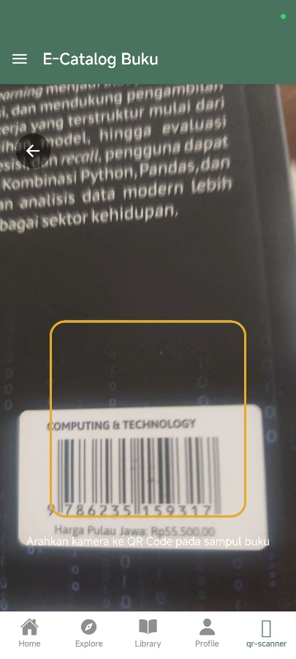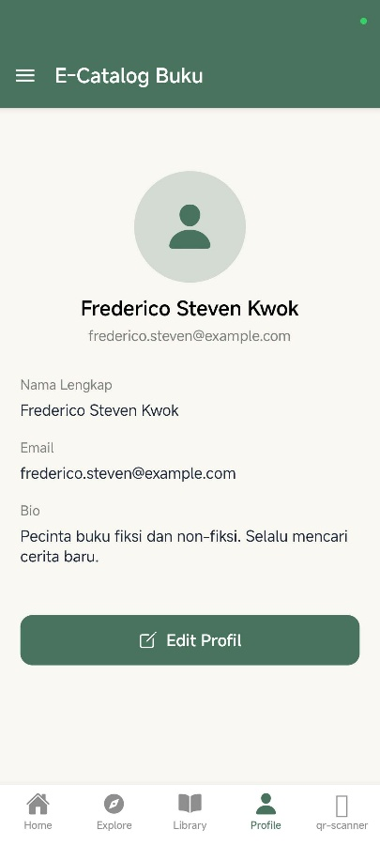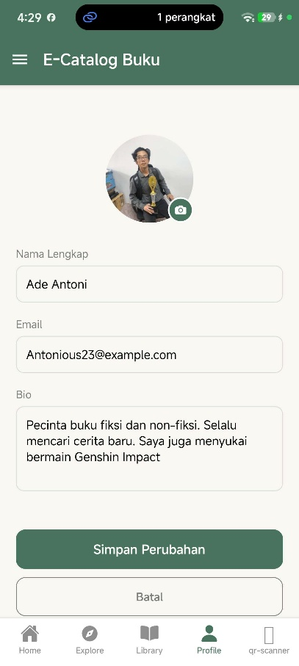
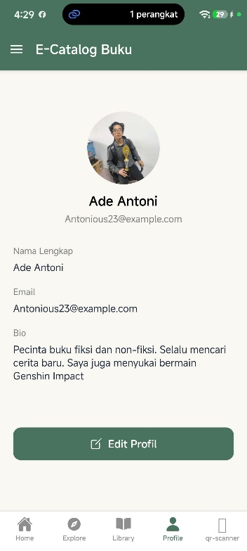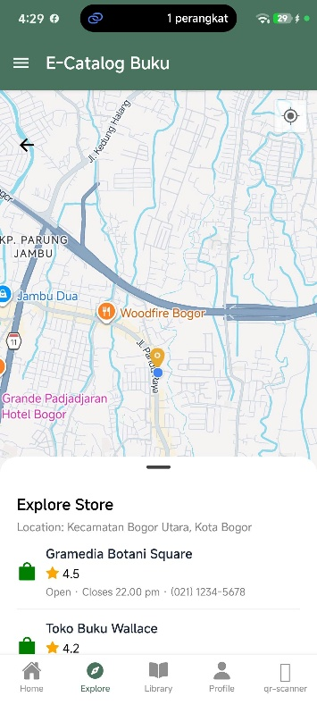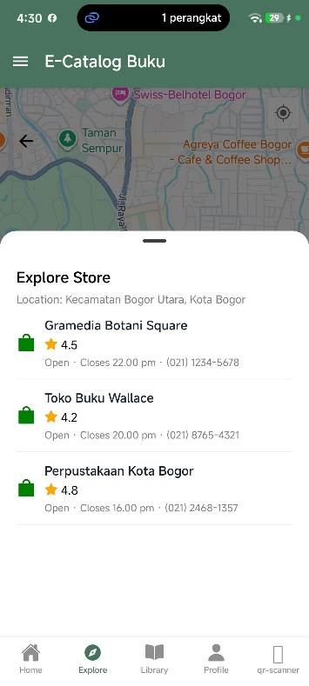
- Upload project tersebut pada GITHUB yang telah dibuat sebelumnya di repository "PPB-Praktikum-NPM", namun commit dengan nama "Tugas Praktikum-7".
- Pengumpulan Tugas Latihan Praktikum dikumpulkan selama 1 minggu kedepan sejak hari ini (sesuai dengan jadwal praktikum).
LINK REPOSITORY
https://github.com/RicoSteven120206/PPB-Praktikum-242310037.git

